**SANGEETHA S PANICKER**

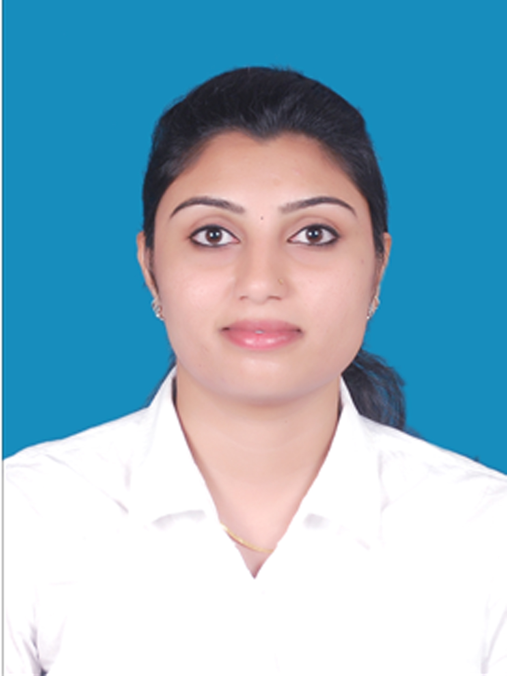

CONTACT: +91 9747752928/9513172778

[sangeethaspanicker8@gmail.com](mailto:sangeethaspanicker8@gmail.com)

**CAREER OBJECTIVE**

To be a part of the challenging team that always awake for the growth and sustenance of the organization where I can provide my long term contribution of ideas and talent by dedicating and coordinating responsibly in the HR domain.

**EXPERIENCE SUMMERY**

**4 years** of work experience in the field of Human Resources including HR Generalist role, HR Administration, Recruitment and Selection procedures, Joining Formalities, Induction, Training, Payroll Processing, Compliance and Statutory policy handling, maintaining MIS Reports, managing Client Services and Software administration & support.

* Worked as **HR Generalist** in **Kitex Garments Ltd, Kizhakkambalam, Aluva**.
* **HR/Payroll Executive,** in **Ascent Consulting Services Pvt Ltd, Bangalore**.
* **HR and Administration Executive** with **Voltech HR Services Pvt Ltd, Vytila and International Display Systems, Bahrain**
* **Software Developer, in** Wipro Technologies, Bangalore and Kochi.

## HR GENERALIST ACTIVITIES (@ KITEX)

* Recruitment & Joining Formalities including Induction and orientation, Data Entry to Employee Management System, Proof verification , Electronic Photo id card distribution, Bank Account Formalities, Police Verification submission
* Compliance- ESI and PF Registration, Accident Reporting to ESI
* Compensation, OT and Attendance Management
* Plant Visit & Employee Grievance Handling, guidance and query resolving
* Employee File Maintaining and updating
* Company Mediclaim End to end process and coordinating with Vendor Insurance Team
* Maintaining various documentations and committee registers namely, Health and safety, Sexual Harassment Awareness, Accident and First Aid, Fire & Safety for Audit purpose

## END TO END RECRUITMENT (@ KITEX & VOLTEC)

* Coordinating with departmental managers to analyse their human resource requirements and gathering job role specifications and descriptions.
* Sourcing and Screening candidates from online sites, Mass media ads, Company Career sites, Employment agencies and Referrals and Job fairs
* Organizing and conducting Interviews and Selecting, and on-boarding formalities of candidates
* Providing Induction and Orientation to new employees
* Maintaining data tracks and records
* Conducting Exit Interviews

## PAYROLL PROCESS & CLIENT COORDINATION (@ ASCENT)

* Interacting with Clients as the first point of contact through calls and emails and client support (CRM).
* Monthly Payroll information collection, sharing of Various Reports namely, Salary Registers, Bank Schedules, Employee Master, Statutory reports etc.
* Employee Query Management (QMS) related to Payroll including Salary Calculations, Reimbursements, Tax Computations and Investments & proof submissions
* Configuration and administration of the HRSS software for the clients
* Giving Payroll & Tax saving Investment Helpdesk and Presentations at client locations

## TRAINING & DEVELOPMENT ACTIVITIES (@ ASCENT)

* Giving Training for new recruits on Payroll Process, Flexi Components & Reimbursements, Investments declaration and Tax Calculations & Employee Query management and client handling

**ADMINISTRATION ACTIVITIES (@ IDS)**

* Human Resource Generalist activities
* Attendance keeping and leave handling of  employees
* Company account handling including Petty cash, Salaries and Credit system
* Maintenance of all official files
* Official communications as Direct meeting, Emailing, Call receiving and Enquiry with customers and other branches
* Staff management, Coordination of the works at work site like arranging external labours, tools and equipments for site
* Stock management including Preparation and Verification of Materials to be Imported

**IT EXPERIENCE(@ WIPRO)**

* Development of Web-based applications using Java/J2EE technologies and Tool Administration.
* Domain expertise entails to Global Media and Telecom Industry, Software Service.
* Abilities in software development including creation of Change Requests, Work packages and site configuration.
* Experience in NSN IT Research & Development-PDM/PLM, focused on meeting all requirements includes primary meeting of customer needs and coordinating the systems design process by involving all relevant disciplines.
* Hands-on administration on tools –Focal point ( IBM Tool), Windchill 10.1 (PTC Tool for PLM), BMC remedy tool, Team center (Siemens Tool for PLM),JIRA(For Issue tracking and resolving).

**TECHNICAL SKILLS**

* EMS & ERP software- CRM & HRIS Applications like client portals and Investment proof submission tool and Payroll Processing Software
* MS Office – Excel, Word and Power point, Access & Outlook
* Worked on Siemens PLM Tool-TeamCenter, Windchill and IBM tool- Focal Point
* Programming Languages: Core Java, Java J2EE, C, C++, HTML
* Database Tools : Oracle database, MS Access, SQL

**PERSONAL STRENGTH**

* Interpersonal skills, Coordination & Adaptability
* Efficient in communicating thoughts to teammates & Clients, both verbal and written
* Dedicated Smart work with responsibility
* Spirit in working in Team, Coordinating and Managing team
* Knack of planning enabled me to systematically meet deadlines, without being over-burdened while multitasking
* Ease in handling any software application and technical tools
* Initiative taking and Proactive
* High grasping ability and fast performance
* Always ready to learn new skills & knowledge.
* Approach as a Problem Solver

**EDUCATIONAL QUALIFICATION**

* **MBA in HR** and Marketing from Union Christian College, Aluva (70%) Aug 2017
* **Advanced Diploma Certification in HR** (Core HR, HR Generalist & Payroll) Aug 2017
* **BSc Computer Science** from Union Christian College, Aluva (72%) Apr 2012
* **GNIIT** Course(Diploma in Software Engineering)from NIIT, N.Paravur
* Higher Secondary Examination from SNDPHSS, Palissery (93.3%) Mar 2008
* 10th from Holy India Foundation School, N. Paravur Mar 2006

**PERSONAL DETAILS**

Father’s Name : K N Sasi

Gender : Female

Nationality : Indian

Marital Status : Married

Languages Known : English, Hindi & Malayalam

Address : Aruvi House, Vayalkara, Kunnukara P O, Ernakulam, Kerala PIN 683578

**DECLARATION**

**DECLARATION**

I hereby declare that the above given information is true to the best of my knowledge.

Date : 07-12-2020

Place : Aluva Sangeetha S Panicker